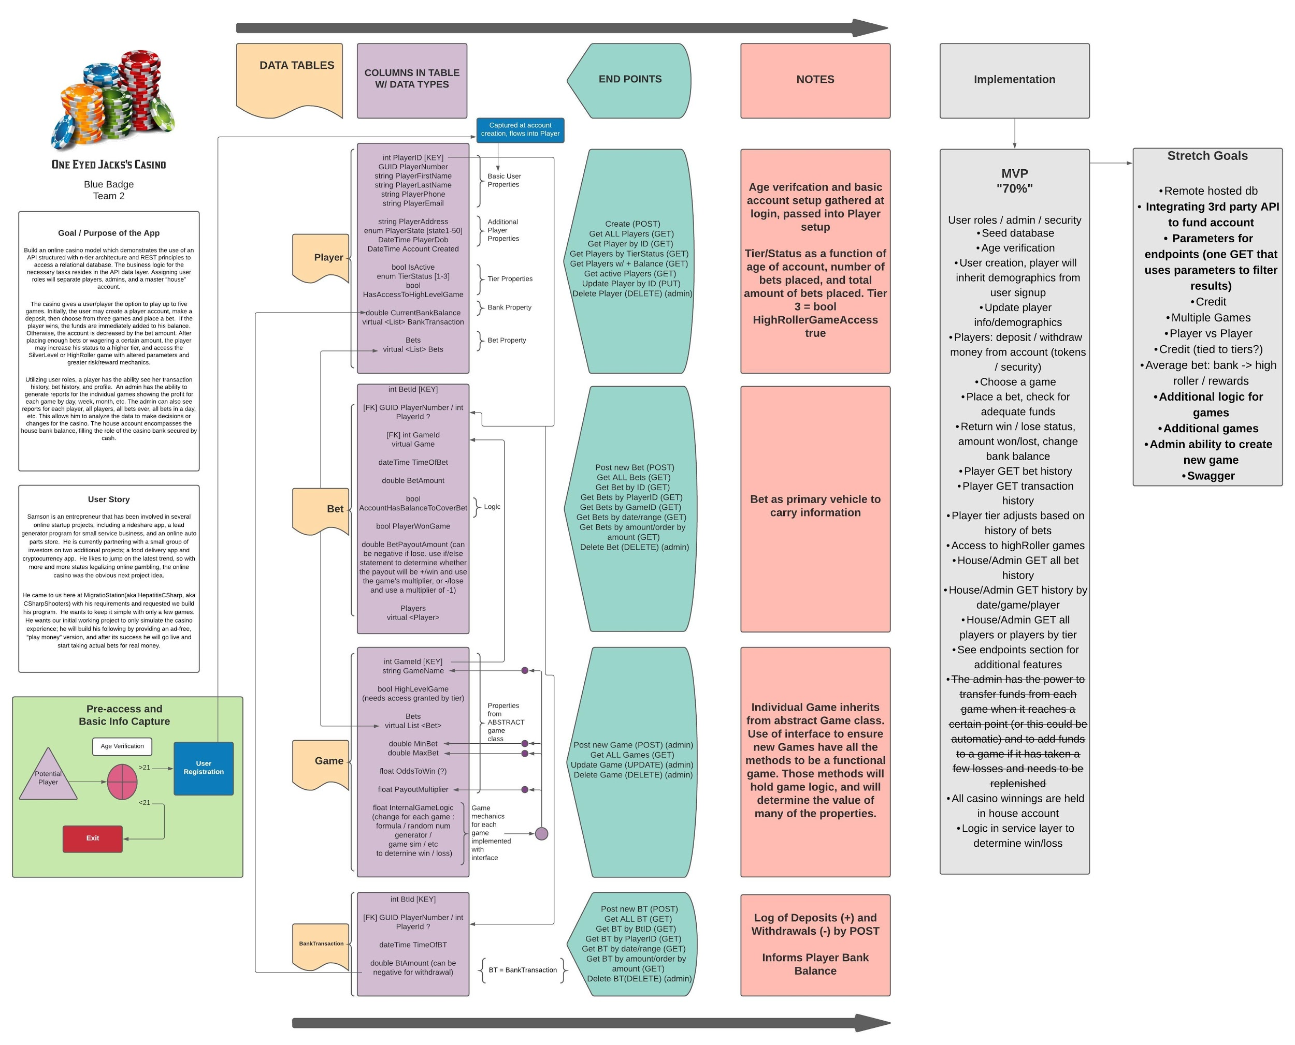

Online Casino

Brian Campassi, Joshua Hartman,
Jonathan Dikteruk, Eric Bella

Table of Contents

Table of Contents 2
OVERVIEW
3
Mission Statement 3
Database 4
Features 8
Miro Board 8
Trello Link 9
Schedule 9

OVERVIEW

Mission Statement

Build an online casino model which demonstrates the use of an API structured with n-tier architecture and REST principles to access a relational database. The business logic for the necessary tasks resides in the API data layer. Assigning user roles will separate players, admins, and a master “house” account.

The casino gives a user/player the option to play up to three games. Initially, the user may create a player account, make a deposit, then choose from three games and place a bet. If the player wins, the funds are immediately added to his balance. Otherwise, the account is decreased by the bet amount. After placing enough bets or wagering a certain amount, the player may increase his status to a higher tier, and access the SilverLevel or HighRoller game with altered parameters and greater risk/reward mechanics.

Utilizing user roles, a player has the ability see her transaction history, bet history, and profile. An admin has the ability to generate reports for the individual games showing the profit for each game by day, week, month, etc. The admin can also see reports for each player, all players, all bets ever, all bets in a day, etc. This allows him to analyze the data to make decisions or changes for the casino. The house account encompasses the house bank balance, filling the role of the casino bank secured by cash.

User Story

Samson is an entrepreneur that has been involved in several online startup projects, including a rideshare app, a lead generator program for small service business, and an online auto parts store. He is currently partnering with a small group of investors on two additional projects; a food delivery app and cryptocurrency app. He likes to jump on the latest trend, so with more and more states legalizing online gambling, the online casino was the obvious next project idea.

He came to us here at MigrationStation(aka HepatitisCSharp, aka CSharpShooters) with his requirements and requested we build his program. He wants to keep it simple with only a few games. He wants our initial working project to only simulate the casino experience. Samson will build his client base by providing an ad-free “play money” version, and after its success and following the navigation of the labyrinthe regulatory process, he will go live and start taking actual bets for real money.

Agile Principles

The team elected to use agile principles in the development of the online casino. The project is divided into one sprint, with clear delineated goals for each week. At the end of the sprint, the product will be delivered as a successful demonstration of a casino simulation. Internally, we will have acquired greater insight into the development life cycle, and how we could have improved processes to create a deliverable faster and more efficiently. We have developed a user story that defines how the system should be developed to meet the stated need of the requisitioning user. As a team, we have presented how the solution should work and interact with users through our Miro and Lucid boards. We are working collaboratively as a team to divide the work at each stage of the development process to prevent placing the onus on one individual.

Database
Table 1 (inherits from UserSetup)
Player
PlayerId
PlayerNumber
PlayerFirstName
PlayerLastName
PlayerPhone
PlayerEmail
PlayerAddress
PlayerState
PlayerDob
AccountCreated
IsActive
TierStatus
HasAccessToHighLevelGame
CurrentBankBalance
BankTransactions
Bets
EligibleForReward ** (stretch goal)
AgeVerification (pre-signup but also function of DOB >= 21)

Table 2
Bet
BetId
PlayerId
GameId
TimeOfBet
BetAmount
AccountHasBalanceToCoverBet
PlayerWonGame
BetPayoutAmount

Table 3
Game
GameId
GameName
HighLevelGame
Bets
MinBet
MaxBet
OddsToWin
PayoutMultiplier
InternalGameLogic

Table 4
BankTransaction
BtId
PlayerId
TimeOfBT
BTAmount

Wireframe: (Data Tables / Classes with Properties, End Points, Notes, MVP vs Stretch)__

Endpoints
Player:
Create (POST)
Make a deposit (POST)
Make a withdraw (POST)
Get players in order of lifetime warnings or amount they have bet or provide specific parameters to search (POST)
Get active Players (GET)
Get a Player by PlayerID (GET)
Get Players by TierStatus (GET)
Get all Players that HasAccessToHighLevelGame (GET)
Get all Players that have a CurrentBankBalance (GET)
Update an existing Player by its ID (PUT)
Delete account by making it inactive (DELETE)
Delete user admin/house accounts (admin management) (DELETE)

Bet:
Post a new bet (POST)
Get all Bets (GET)
Get a Bet by its ID (GET)
Get all Bets by its PlayerId (GET)
Get all Bets by its GameId (GET)
Get bets by date or range (GET)
Get bets by amount or in order by amount (GET)

Game
Create (POST)
Get all Games (GET)
Update a Game by its ID (PUT)
Delete an existing Game by its ID (DELETE)

Transactions
Deposit/Withdraw (POST)
Get all Transactions (GET)
Get Transaction by Player (GET)
Get Transactions by Date (GET)

Features

Version 1.0 / MVP / “70%” | Version 2.0 / Stretch Goals
- User roles / admin / security  - Seed database  - Age verification  - User creation, player will inherit demographics from user signup  - Update player info/demographics  - Players: deposit / withdraw money from account (tokens / security)  - Choose a game  - Place a bet, check for adequate funds  - Return win / lose status, amount won/lost, change bank balance  - Player GET bet history  - Player GET transaction history  - Player tier adjusts based on history of bets  - Access to highRoller games  - House/Admin GET all bet history  - House/Admin GET history by date/game/player  - House/Admin GET all players or players by tier  - See endpoints section for additional features  - The admin has the power to transfer funds from each game when it reaches a certain point (or this could be automatic) and to add funds to a game if it has taken a few losses and needs to be replenished  - All casino winnings are held in house account  - Logic in service layer to determine win/loss | - Remote hosted db  - Credit  - Multiple Games  - Player vs Player  - Credit (tied to tiers?)  - Average bet: bank -> high roller / rewards  - Additional logic for games  - Additional games  - Admin ability to create new game

Miro Board
https://miro.com/app/board/o9J_IVAL6MU=/

Lucid Wireframe
https://lucid.app/lucidchart/invitations/accept/76e58e9f-5271-4a03-90c9-07302b566b4c

Trello Link
- Currently using Miro and Lucid

Schedule

 | 1 | 2 | 3 | 4 | 5 | 6
 |  |  |  |  |  | Project Assigned
7 | 8 | 9 | 10 | 11 | 12 | 13
Brianstorm Ideas |  | Choose Project! | Begin Planning/  Wirefame/  Flowchart/  Doc |  | Revise/  Simplify/  Choose 70% | Research/  Revise
14 | 15 | 16 | 17 | 18 | 19 | 20
 | Completed  First draft of wireframe and planning doc | Revise/  Final draft of planning doc and wireframe.  PITCH | Revisions if necessary | Planning doc DUE TODAY  Delegate workload to team members | Team GIT  Initial framework build and clone | Push
21 | 22 | 23 | 24 | 25 | 26 | 27
Push | Merge  Pull  All classes built and functional including all POCOS, controllers, models, and service. | A working product that we can all be testing by this point. | Begin Debug of our working product. Fix/tweak as needed before moving on to our stretch goals. | Continue Testing |  | Complete phase. If we had to turn it in today, we have a “A” project that we are proud of.  *Begin stretch goals.
28 | 1 | 2 | 3 | 4 | 5 | 6
Choose 1-2 goals |  | Finish first 2 goals | Choose 2 more goals |  | Finish with next 2 goals. | Fully test project with the new features.
7 | 8 | 9
Final touches. Add ReadMe |  | DUE DATE  Congratulations!

